What is the Difference between TCP and IP?

.
Connecting a computer to a router
2.
Connecting a computer to a computer
3.
Connecting a router to a router
4.
Connecting a switch to a switch
5.
Connecting a hub to a hubWhile the rule of thumb is to use crossover cables with like devices, some devices do not follow standards.Others provide support for both types of cables. However, there is still something that both crossover and straight-through cables can’t do.

Connecting a router to a hub
2.
Connecting a computer to a swtich
3.
Connecting a LAN port to a switch, hub, or computer
The basic difference between TCP (Transmission Control Protocol) and IP (Internet Protocol) is in the transmission of data. In simple words, IP finds the destination of the mail and TCP has the work to send and receive the mail. UDP is another protocol, which does not require IP to communicate with another computer. IP is required by only TCP. This is the basic difference between TCP and IP.

TCP/IP Model:
1. Physical Layer
1. This layer is responsible for generating the data and requesting connections.
2. It acts on behalf of the sender and the Network Access layer on the behalf of the receiver.
2. Data Link Layer:
1. Error prevention and “framing” are also provided by the data-link layer.
2. Point-to-Point Protocol (PPP) framing and Ethernet IEEE 802.2 framing are two examples of data-link layer protocols.
3. Internet/ Network Layer:
1. It defines the protocols which are responsible for the logical transmission of data over the entire network
2. The Internet Layer is responsible for routing packets of data from one device to another across a network. It does this by assigning each device a unique IP address, which is used to identify the device and determine the route that packets should take to reach it.
IP , ICMP , ARP
4. Transport Layer:
1. The TCP/IP transport layer protocols exchange data receipt acknowledgments and retransmit missing packets to ensure that packets arrive in order and without error.
2. Transmission Control Protocol (TCP) and User Datagram Protocol are transport layer protocols at this level (UDP).
5. Application Layer:
HTTP, HTTPS, SSH, NTP ( Network Time Protocol )

Router
The router is a physical or virtual internetworking device that is designed to receive, analyze, and forward data packets between computer networks. A router examines a destination IP address of a given data packet, and it uses the headers and forwarding tables to decide the best way to transfer the packets.
Uses IP address
Layer : 3
Protocols : ICMP,
Switches:
Switches are networking devices operating at layer 2 or a data link layer of the OSI model. They connect devices in a network and use packet switching to send, receive or forward data packets or data frames over the network.
It supports unicast, multicast as well as broadcast communications.
Transmission mode is full duplex, i.e. communication in the channel occurs in both the directions at the same time. Due to this, collisions do not occur.
Uses MAC address
Layer :2
Types of Switches:
1. Managed switch
2. Unmanaged switch

Hubs:
A hub is a physical layer networking device which is used to connect multiple devices in a network. They are generally used to connect computers in a LAN.
A hub has many ports in it. A computer which intends to be connected to the network is plugged in to one of these ports. When a data frame arrives at a port, it is broadcast to every other port, without considering whether it is destined for a particular destination or not.

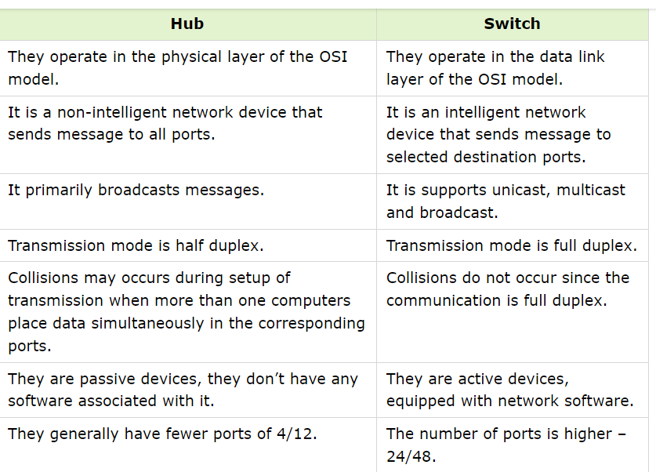

Network ID:
A network ID is the fragment of IP address that classifies the network for a specified host i.e., it tells us which network the host belongs to, generally comprised of one to up to four octets in dotted-decimal representation.
Broadcast ID:
A broadcast address refers to a special IP address that is used to send a message or packet to all devices on a network. Broadcast addresses are commonly used for network management tasks, such as sending out configuration updates or discovery requests.
Subnet Mask:
A subnet mask is a four-octet number used to identify the network ID portion of a 32-bit IP address created by setting the host bits to all 0s and setting network bits to all 1s. In this way, the subnet mask separates the IP address into the host address and network address
Subnetting:
It is a technique in which a single physical network is logically partitioned into multiple smaller subnetworks or subnets. By adding subnets without a new number, an organization enables subnetting for the purpose of concealing the network complexity and reducing the network traffic. Subnetting is essential when a single network number is used across many segments of a local area network.
Advantages of Subnetting:

MAC address :
MAC address is the physical address, which uniquely identifies each device on a given network. To make communication between two networked devices, we need two addresses: IP address and MAC address. It is assigned to the NIC (Network Interface card) of each device that can be connected to the internet.
It is globally unique; it means two devices cannot have the same MAC address.
It is 12-digit, and 48 bits long, out of which the first 24 bits are used for OUI(Organization Unique Identifier), and 24 bits are for NIC/vendor-specific
The ARP protocol is used to associate a logical address with a physical or MAC address.
It is represented in a hexadecimal format on each device, such as 00:0a:95:9d:67:16.
Reason to have both MAC and IP:
Both MAC and IP addresses are operated on different layers of the internet protocol suite. The MAC address works on layer 2 and helps identify the devices within the same broadcast network (such as the router). On the other hand, the IP addresses are used on layer 3 and help identify the devices on different networks.
We have the IP address to identify the device through different networks, we still need a MAC address to find the devices on the same network.
IP Address:
An IP address is a unique address that identifies a device on the internet or a local network. IP stands for "Internet Protocol," which is the set of rules governing the format of data sent via the internet or local network.
IP addresses are not random. They are mathematically produced and allocated by the Internet Assigned Numbers Authority (IANA),
Private IP Address:
Every device that connects to your internet network has a private IP address. This includes computers, smartphones, and tablets etc . Your router needs a way to identify these items separately, and many items need a way to recognize each other. Therefore, your router generates private IP addresses that are unique identifiers for each device that differentiate them on the network.
Public IP Address:
Your public IP address is the address that all the devices outside your internet network will use to recognize your network.
your public IP address is provided to your router by your ISP. Typically, ISPs have a large pool of IP addresses that they distribute to their customers.
Static IP Address:
In contrast to dynamic IP addresses, static addresses remain consistent. Once the network assigns an IP address, it remains the same. Most individuals and businesses do not need a static IP address, but for businesses that plan to host their own server, it is crucial to have one.

Dynamic IP addresses
Dynamic IP addresses change automatically and regularly. ISPs buy a large pool of IP addresses and assign them automatically to their customers. Periodically, they re-assign them and put the older IP addresses back into the pool to be used for other customers. The rationale for this approach is to generate cost savings for the ISP

Straight Cables:
Out of the 8 pins that exist on both ends of an Ethernet cable, each pin connects to the same pin on the opposite side.
Use:
Connecting a router to hub
Connecting a computer to switch
Connecting a LAN port to switch hub or router
Crossover Cables:

Note that some devices such as routers will have advanced circuitry, which enables them to use bothcrossover and straight-through cables. In general, however, straight-through cables will not connect acomputer and router because they are not “unlike devices.

Use :
Connecting router to router
Connecting switch to switch
Rollover cables essentiallyhave one end of the cable wired exactly opposite from the other Connecting hub to hub
Connecting computer to computer

Rollover Cables:
Rollover cables essentiallyhave one end of the cable wired exactly opposite from the other
Rollover cables, also called Yost cables, usually connect a device toa router or switch’s console port. This allows a programmer to make a connection to the router or switch,and program it as needed.

VLAN:
Virtual LAN (VLAN) is a concept in which we can divide the devices logically on layer 2 (data link layer). Generally, layer 3 devices divide the broadcast domain but the broadcast domain can be divided by switches using the concept of VLAN.
To forward out the packets to different VLAN (from one VLAN to another) or broadcast domains, inter Vlan routing is needed. Through VLAN, different small-size sub-networks are created which are comparatively easy to handle.
VLAN ranges:
- VLAN 0, 4095: These are reserved VLAN which cannot be seen or used.
- VLAN 1: It is the default VLAN of switches. By default, all switch ports are in VLAN. This VLAN can’t be deleted or edit but can be used.
- VLAN 2-1001: This is a normal VLAN range. We can create, edit and delete these VLAN.
- VLAN 1002-1005: These are CISCO defaults for fddi and token rings. These VLAN can’t be deleted.
- Vlan 1006-4094: This is the extended range of Vlan

VLANs offer several features and benefits, including:
- Improved network security: VLANs can be used to separate network traffic and limit access to specific network resources. This improves security by preventing unauthorized access to sensitive data and network resources.
- Better network performance: By segregating network traffic into smaller logical networks, VLANs can reduce the amount of broadcast traffic and improve network performance.
- Simplified network management: VLANs allow network administrators to group devices together logically, rather than physically, which can simplify network management tasks such as configuration, troubleshooting, and maintenance.
- Flexibility: VLANs can be configured dynamically, allowing network administrators to quickly and easily adjust network configurations as needed.
- Cost savings: VLANs can help reduce hardware costs by allowing multiple virtual networks to share a single physical network infrastructure.
- Scalability: VLANs can be used to segment a network into smaller, more manageable groups as the network grows in size and complexit

